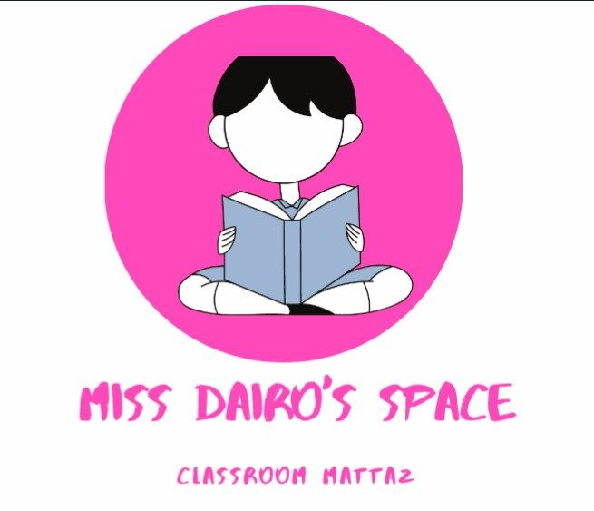
MISS DAIRO'S CLASSROOM
(MY DIVISION STORY)

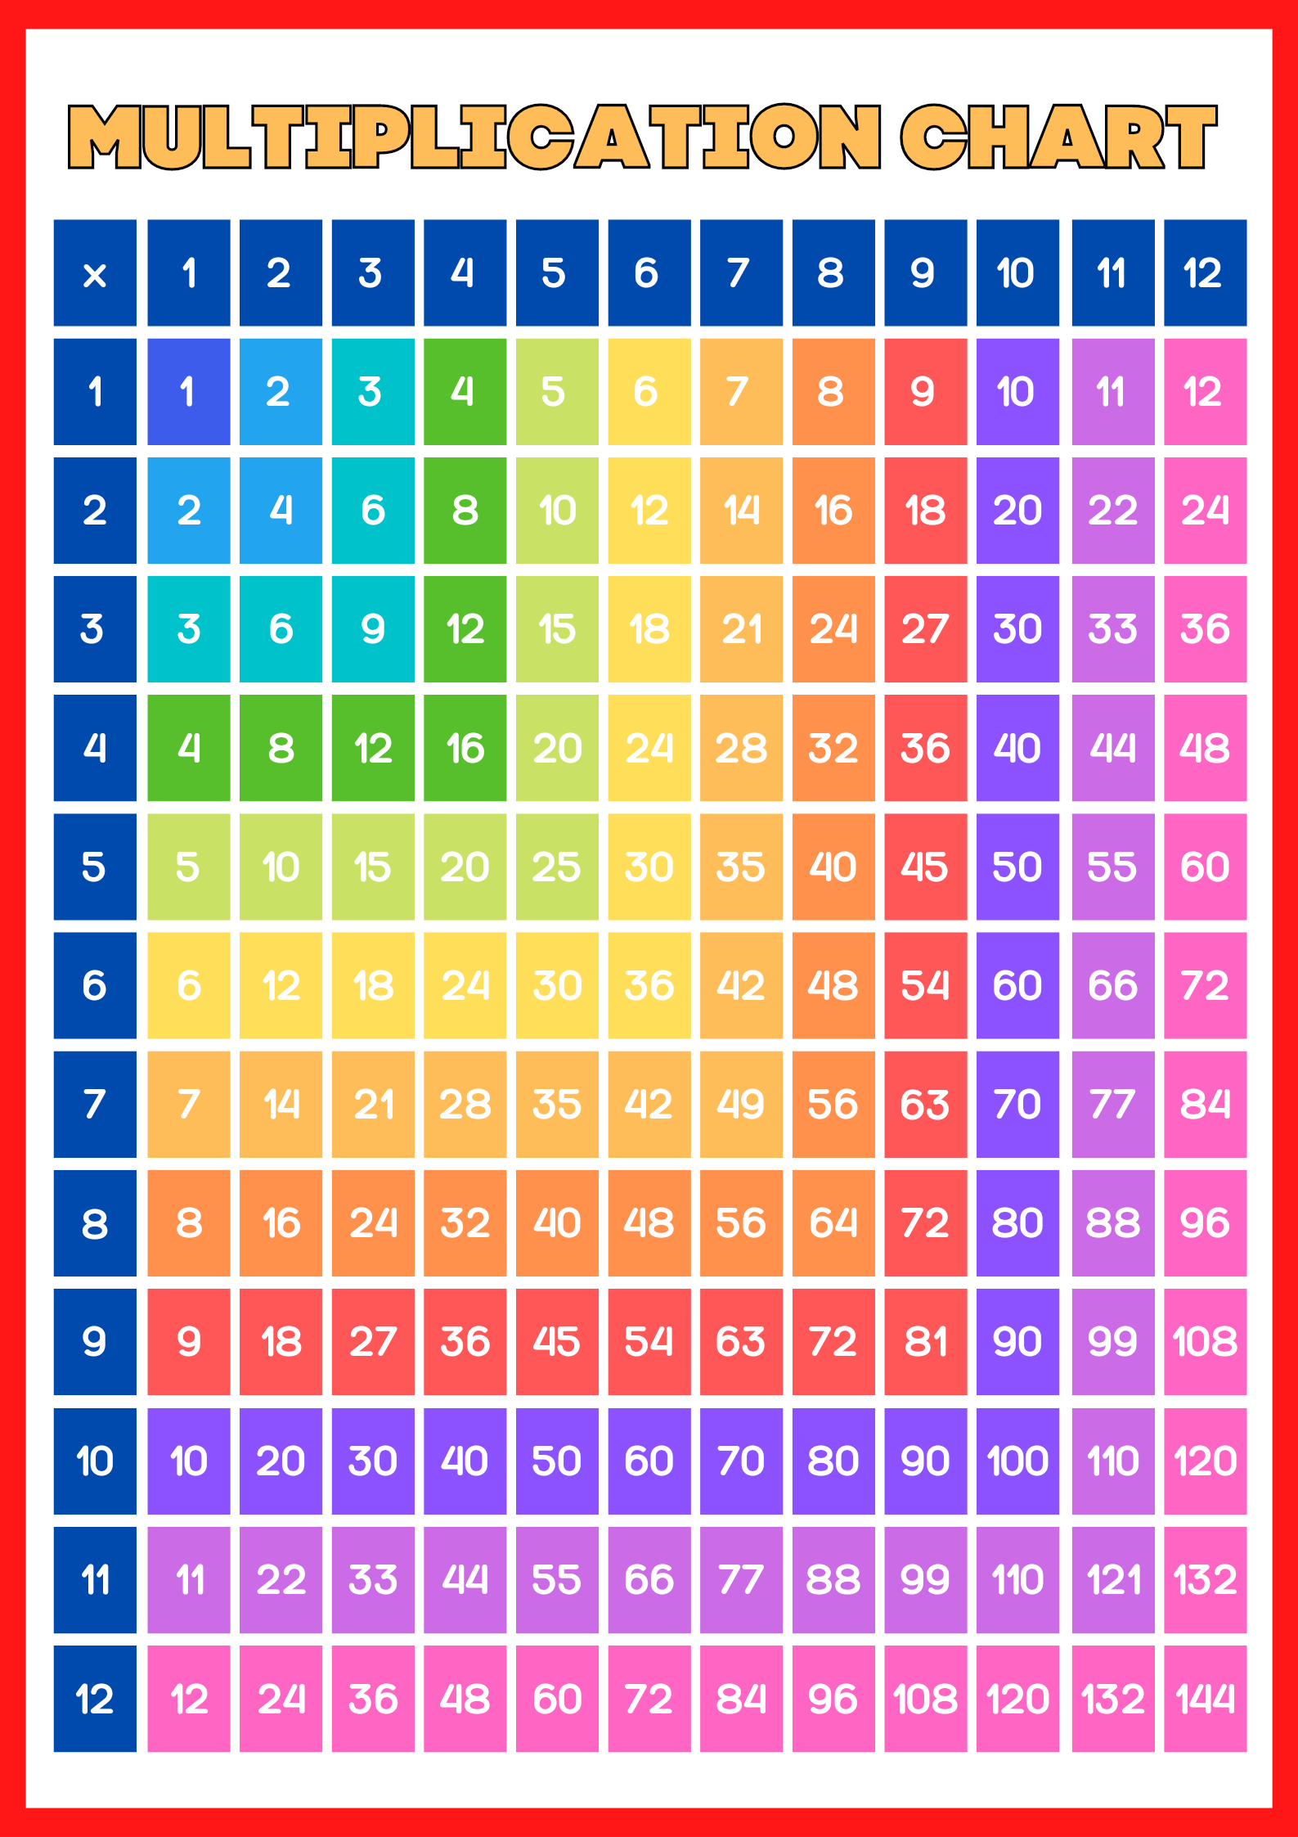

MULTIPLICATION ACTIVITY
